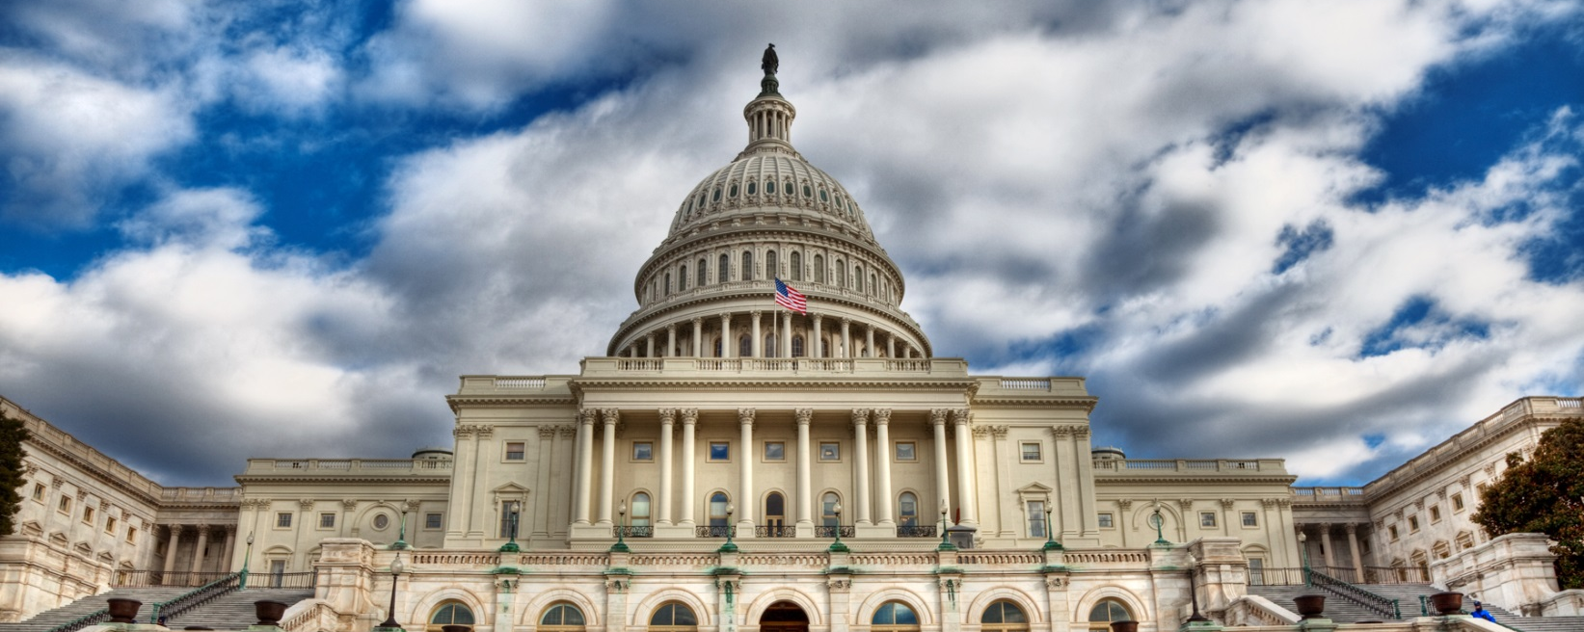

National Association of Health Underwriters
2018 Capitol Conference -- February 26-28 -- Washington, D.C.
Preliminary Agenda
Sunday, February 25
6:00–8:00 p.m. Attendee Welcome Reception
8:00–11:00 p.m. HUPAC Bowling Party

Monday, February 26
7:30 a.m.–5:00 p.m. Registration
7:30–8:00 a.m. Continental Breakfast with Sponsors
8:00–9:00 a.m. Breakout Meetings for:
- State and Local Legislative Chairs
  - This meeting will serve as a training session for new and current state and local legislative chairs. It will include a panel of experienced legislative chairs, a review of the manual, and presentation of new state tracking services.
- HUPAC Chairs
9:15–11:30 a.m. General Session
12:00–1:15 p.m. Lunch on own
1:30–2:45 p.m. Town Hall Meeting
2:45–3:15 p.m. Afternoon Break with Sponsors
3:15–4:45 p.m. Breakout Session
5:00–6:00 p.m. NAHU Regional Meetings
6:00 p.m. Dinner on your own

Tuesday, February 27
7:00–8:00 a.m. Continental Breakfast with Sponsors
8:00–11:30 a.m. General Session
11:30 a.m.–1:00 p.m. Lunch on your own
1:00–5:00 p.m. Lobbying on Capitol Hill
- Member-arranged visits with congressional representatives.
5:30–7:30 p.m. HUPAC Reception at the Top of the Hill (ticket required)

Wednesday, February 28
7:00–8:00 a.m. Continental Breakfast with Sponsors
8:00–11:30 a.m. General Session
11:30 a.m.–1:00 p.m. Lunch on your own
12:00–2:30 p.m. HUPAC Capitol Club Luncheon (by invitation)
1:00–5:00 p.m. Lobbying on Capitol Hill
- Member-arranged meetings with congressional offices.

